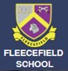
Other General Information
Fire and emergency evacuation:
A copy of the fire procedure and directions to the assembly point can be found in every room. Please familiarise yourself with it on arrival. If the fire alarm sounds, a continuous ring, please leave the building immediately following the emergency exit signs to the nearest exit and assemble on field. Students will line up in their classes. Visitors will be directed to the visitor’s registration area by a member of staff.
First Aid:
Please ask at the Welfare Office if you need assistance. If covering a lesson and a child is taken ill please call or send two students to the Welfare Office to ask for assistance.
Accidents & Incidents:
Please report these to the Office Team.
Access to the Internet:
All users of the school systems and Wi-Fi must comply with the E- Safety Policy. Please ask our safeguarding team for details.
Visitors’ Toilets:
Located on the ground floor and first floor. Please ask Office Team for directions.
Parking & Disabled Access:
Limited parking is available in our car park, but spaces can be reserved if necessary.
There is a ramp or flat access to all the main buildings.
The first floor can be accessed via a lift.
Reporting defective equipment or hazards:
Please report these to the Office Team.

Please sign in on arrival and collect a visitor’s badge. Please wear the badge at all times to avoid being challenged by staff or students.
RED LANYARD - MUST BE ACCOMPANIED – NOT DBS CHECKED
GREEN LANYARD – DBS CHECKED – VETTING
INFORMATION ON FILE (Enfield schools personnel, Governors etc.)
BLUE LANYWARD – DBS CHECKED – Regular
staff and/or visitors to the school (S&L Therapists, OH Therapists, NHS Staff, Relief/ Supply staff etc.)
On departure, please sign out and return your badge.

Visitor & Safeguarding Information

Welcome to Fleecefield Primary School
Please take a few moments to read this leaflet. We are committed to safeguarding and promoting the welfare of our children and this requires all staff and visitors to demonstrably share this commitment.
Contained in this leaflet is information about our child protection and safeguarding procedures and guidance on what you should do if you have any concerns.

Disclosure
If a student discloses information about significant harm you should:
- Listen
- Tell the student that you need to tell someone else — you cannot promise confidentially
- Make accurate notes of what has been said by the student (in their own words) and pass this immediately to a member of the safeguarding team (Office team can give directions)
It is not your responsibility to investigate but to report to the Safeguarding Team.
Safeguarding Team:

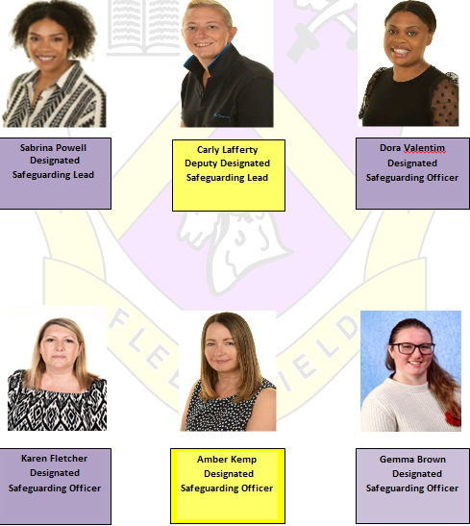

What is Abuse?
Any form of neglect, physical, emotional or sexual mistreatment or lack of care that leads to harm or injury. It can happen to any child regardless of their age, gender, race or ability.
What is discrimination?
Direct discrimination is where you are treated less favourably because of your disability than someone without a disability would be treated in the same circumstances and there is no justification. This also covers race, ethnic or national origin, language, religion or belief, gender, gender reassignment, sexual orientation, disability, social class, responsibility for other dependants or where the person lives.
What is bullying?
A willful, conscious attack on the self-esteem or the person of an individual student. It includes jibes, name -calling, silence/exclusion from the social circle, emphasising differences, threatening behavior, racial/sexual harassment, extortion and physical attack. It may vary in severity, frequency and in the numbers of people involved.
People working in schools are uniquely placed to notice signs and symptoms of abuse and to support children who are subject to abuse or living in abusive situations.
Keeping everyone safe
We hope that you have an enjoyable visit to Fleecefield. Our main priority is to ensure that everyone who visits is aware of their responsibilities towards making sure all children are safe. As a visitor please remember the following:
- If you are working in a 1:1 situation with a student, we must have confirmation that all the necessary safeguarding checks have been carried out, including the Enhanced DBS disclosure.
- You must not have any physical contact with any student.
- You must never exchange personal contact details with a student or arrange to meet them outside of the school environment or connect with them via social media.
- The use of cameras and taking photographs is not permitted unless prior permission has been sought.
Fleecefield Primary School
Brettenham Road N18 2ES
Telephone: 0208 807 7899

Executive Headteacher:
Antoinette Goldwater

Associate Headteacher:
Carly Lafferty

Email: office@fleecefield.enfield.sch.uk
Website: https://www.fleecefield.enfield.sch.uk/
Safeguarding Children
As a visitor to our school, either as a contractor, volunteer, supply teacher or someone that has come to work with our children in any capacity, it is important that you are aware of our safeguarding procedures.
- Please refer to the back page of this leaflet for contact details of our child protection team. Or, please contact the office team who can locate them for you.
- If there is any reason to suspect that a student has suffered bullying /child on child abuse, sexual harassment or discrimination, or is likely to suffer significant harm, you must inform the Safeguarding Team immediately. Our staff will then follow the procedures according to the school Safeguarding Policy.
Please share any concerns with the safeguarding team. If you remember anything at a later stage, please contact: Safeguarding@fleecefield.enfield.sch.uk

