Reception Yearly Overview 2024/2025
 | Autumn 1 | Autumn 2 | Spring 1 | Spring 2 | Summer 1 | Summer 2
Topic | All About Me  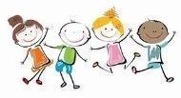 | On the Move  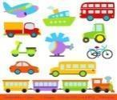 | To the Rescue   | Animal Kingdom  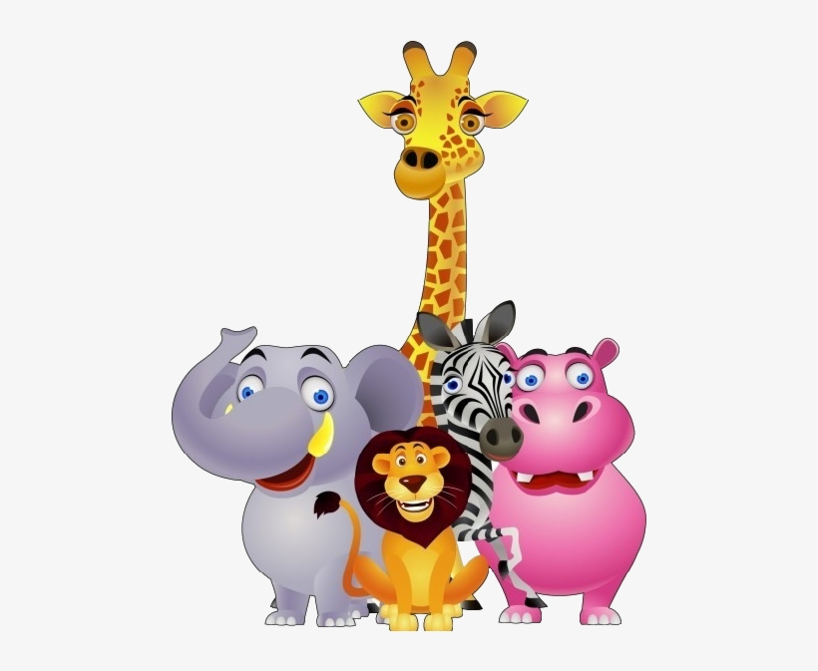 | Marvellous Minibeasts  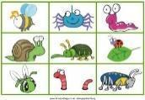 | Food Glorious Food  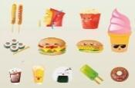
Hook | Bring in a photo of your family. Display in Classroom and show and tell.  Invite families in to show photos of child’s life journey | Train ride from Silver Street Station to Enfield Town. | Dress up day – dress as your favourite hero. | A visit to the Pet Shop/a visit to school from a pet. | Minibeast hunt at Craig’s Park.  Zoolab visit to school. | Trip to Pizza Express.  Cultural food day/assembly  Cultural boxes.  Bring in cultural food-tasting.  Cultural dress day
Events/  Celebrations | Harvest Festival  7/10  Black History Month (October) | Halloween 31/10  Guy Fawkes Night 05/11  Diwali 31/10-01/11  Thanksgiving 28/11  Hanukkah 25/12-02/01  Christmas 25/12 | Chinese New Year 29/01-12/2  Valentine’s Day 14/02  Pancake Day 04/03 | World Book Day 06/03/25  Mothering Sunday  30/03/25  St Patrick’s Day 17/03  Easter 20/04 /25  Ramadan 28/02-29/03/25 | St Georges day  28/04/25 | Father’s Day  15/06/25  Eid ( 5-9/6/ 2025)
Core Books | 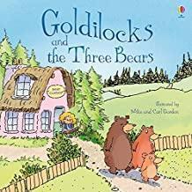  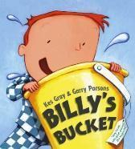  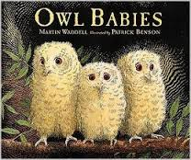  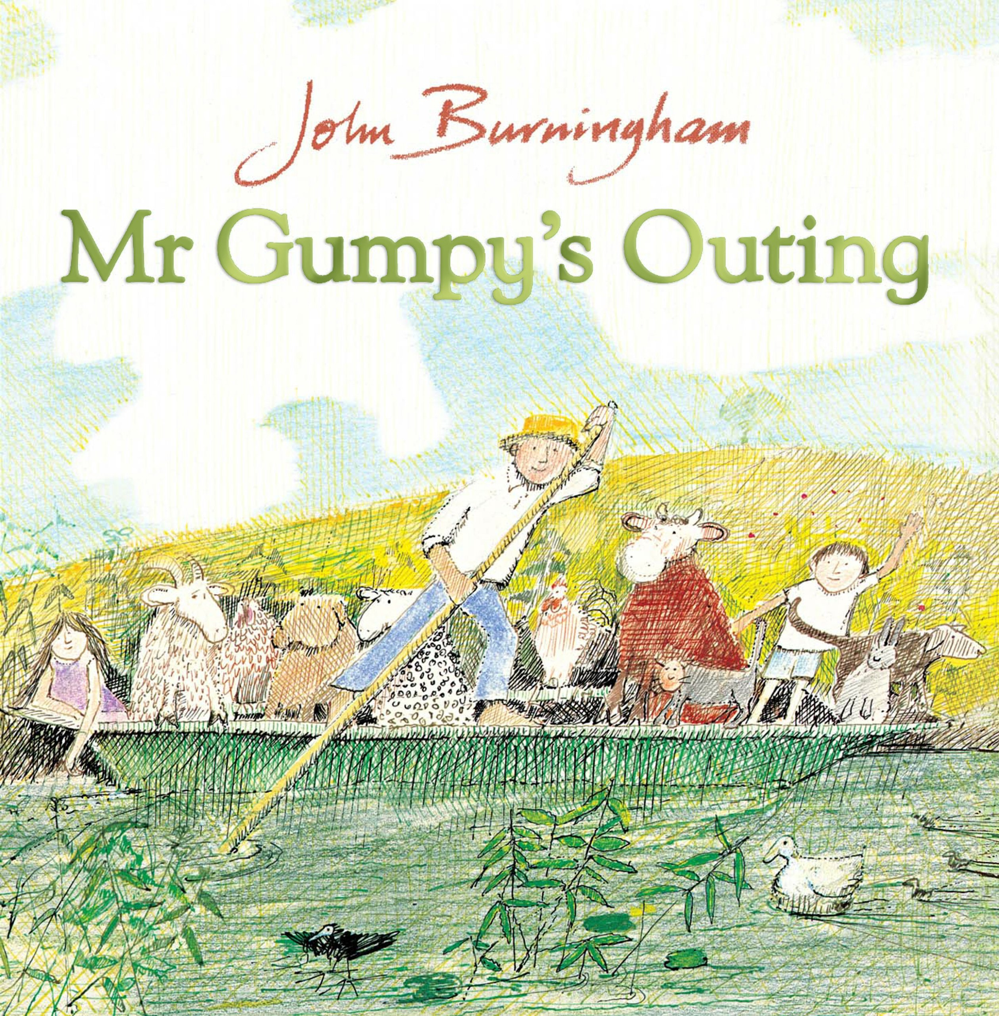 | 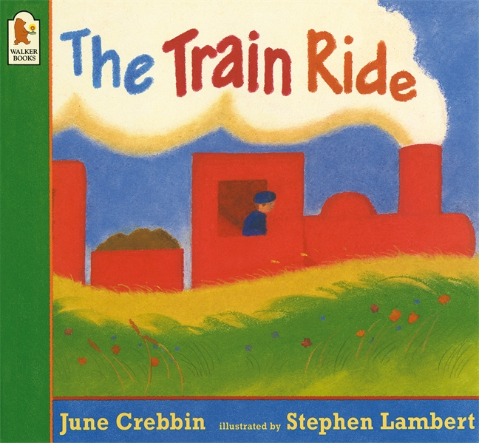  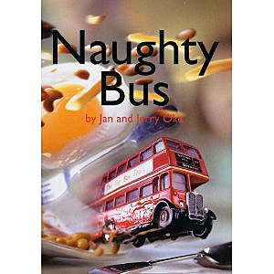  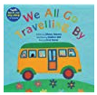 | 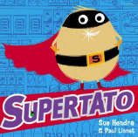  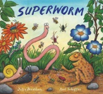  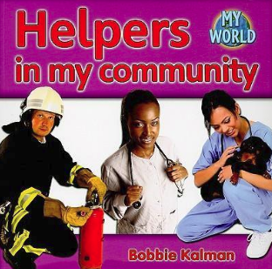  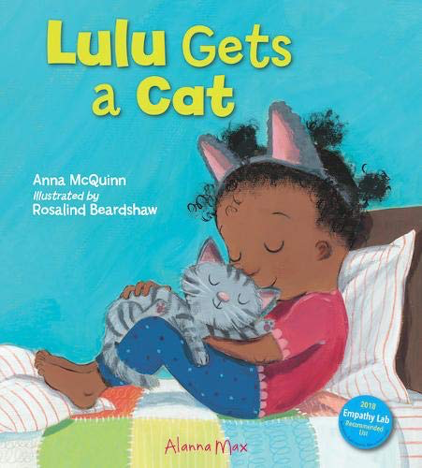 | 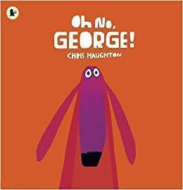  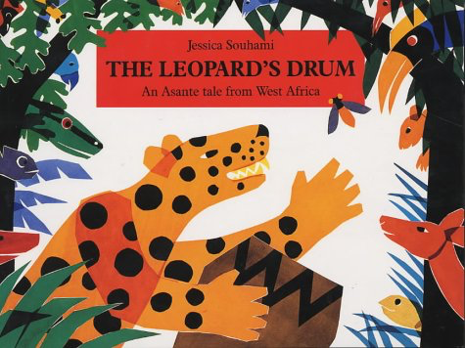 | 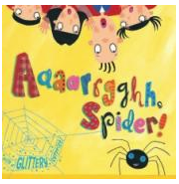  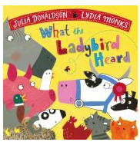  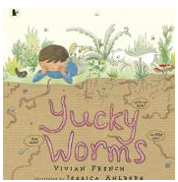 | 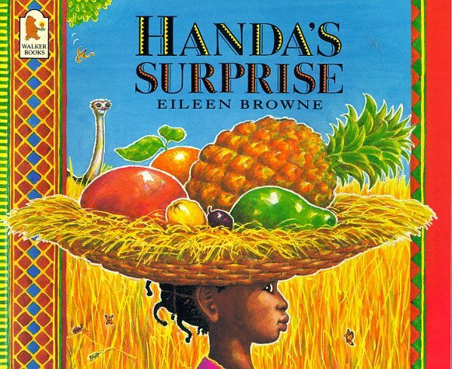  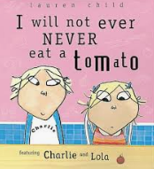  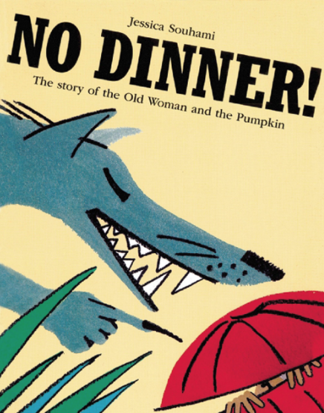  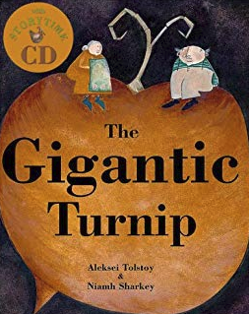  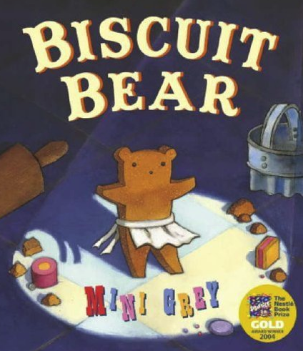
Literacy
 | •hearing and writing initial sound  - linking a few letters to sounds  - recognising own name  - recognising a few high frequency words  - Writing own name  - Begin to write CVC words | - recognise familiar words and signs such as logos/ symbols  - hearing initial sound and know which letters represent some of the sounds  - reading simple CVC words  - begin to show understanding of words read  - recognising and writing some high frequency words | - hearing sounds in words and know which letters represent some of the sounds  - reading longer words such as CVCC and CCVC  - show understanding of words read  - read and write some high frequency words  - introduction to reading simple sentences  - writing simple CVC words  - introduction to writing simple sentences | - hearing sounds in words and know which letters represent the sounds  - naming and sounding the letters of the alphabet  - reading and writing longer words such as CVCC, CCVC and CCCVC  - show understanding of words/sentences read  - read and write some high frequency words  - introduction to reading and writing simple sentences  - making phonetically plausible attempts at writing words | - naming and sounding the letters of the alphabet and some digraphs  - hearing sounds in words and know which letters represent the sounds  - read and write a range of high frequency words  - reading and writing sentences with some fluency | - naming and sounding the letters of the alphabet and some digraphs  - read and write a range of high frequency words  - reading and and making plausible attempts at writing longer words such as blanket and rabbit  - reading and writing own sentences with some fluency, beginning to take note of punctuation  - show understanding of sentences read  - beginning to use connectives and wow words in writing  - showing awareness of different types of writing i.e. stories, letters, instructions etc.
Maths Mastering
 | Baselines /Maths Mastering assessments  -Subitising  - counting, cardinality and composition  -Comparison | -counting  ,ordinality and cardinality  -comparison  composition | -Subitising  - counting, cardinality and -composition  -Comparison | - | -counting  ,ordinality  -and cardinality  --Subitising  --composition  -Comparison | -recap-  comparison  -review-assess  *-recap-counting  -review-assess  *-recap-patterns  -review-assess  *-recap-recall  -review-assess  *-recap-  understanding  -review-assess  Maths Mastering assessments
 | Just like me | Light and Dark | Growing 6,7,8 | Consolidation | First, then, now | On the move
Knowledge and Understanding of the World | 0
Science | -Name and label body parts  -Body parts singing and games (EAD link)  -Self portraits (EAD link)  -Similarities and differences with each other | Transport museum - How do vehicles move? (The Naughty Bus) (On the Move) (Mr Gumpys outing)  Science museum - Rockets, astronauts, dinosaur workshop  Taking the overground - experiencing different types of transport  Bike project/ activity | Making Kites/ paper aeroplanes - flying them indoors and outdoors- where does it fly better- why? | -Naming and labelling parts of animals (Literacy link)  -The 6 basic animal groups  Zoo trip  Willows Farm  Trent Park  Pet shop in Edmonton Green | -Naming different minibeasts and parts of minibeasts  Zoolab Visit  Caterpillars  Nature visits  Text link: Yucky Worms, The Very Hungry Caterpillar | -Growing plants and identifying what plants need to grow  -Compost making – links to Geography  -‘Vegetable patches’, planting bulbs and vegetables  Text link: Jack and the Beanstalk/Jaspers Beanstalk  Science week- see PP
History | Autumn 1 – All About Me  Finding out about families using photos  •Important people – to learn facts about the past life and experiences of significant people in their lives  •How they have changed from birth to present day | Autumn 2 - On the Move  •How transport has changed over time | Spring 1 - To the Rescue  Understand the role of significant people in our community eg doctor/nurse/vet/police/builder/road safety | •Look at animals as babies and adults and compare how they have changed over time | exploring changes over time, comparing past and present, and understanding the concept of life cycles. Children can learn about the history of insects, discover how minibeast habitats have changed, and investigate how these creatures have adapted to their environments. Additionally, they can explore how humans have interacted with minibeasts throughout history. | Summer 2 - Food Glorious Food  Chronological timeline of growing a bean/cress plant
Geography | •Know about human features of immediate environment – home, classroom, shop, Edmonton (London?) (& farms) | •Identify aspects of seasons and weather – hot, cold, rain, wind etc | •Issue – human effect on/looking after our immediate environment | •Identify land and sea on globes/maps and animals who live on land or sea | •Know about some physical features & landscapes – rivers, forests, deserts, mountains, rainforests. Also features within school grounds, incl forest, slopes, pond etc and habitats of different minibeasts | •Locate the UK on a map  •Locate and find out about other countries – link to children’s cultural backgrounds and food from different countries
RE/Exploring different Cultures | Harvest Festival  7/10  Black History Month (October) | Halloween 31/10  Guy Fawkes Night 05/11  Diwali 31/10-01/11  Thanksgiving 28/11  Hanukkah 25/12-02/01  Christmas 25/12 | Chinese New Year 29/01-12/2  Valentine’s Day 14/02  Pancake Day 04/03 | World Book Day 06/03/25  Mothering Sunday  30/03/25  St Patrick’s Day 17/03  Easter 20/04 /25  Ramadan 28/02-29/03/25 | St Georges day  28/04/25 | Father’s Day  15/06/25  Eid ( 5-9/6/ 2025)
Expressive Arts
Art | Autumn Term: Jackson Pollark Text Link: The noisy Paint Brush-About Kandinsky-progression from Nursery)  Build on from Kandisnky colour mixing from Nursery. |  | Spring Term: Explore the work of Andrew Goldsworthy - make own natural art, transient art (collage, shape, pattern, texture, colour). Text link – Stanley’s stick (& not a Stick) Trip to Epping Forest |  | Summer Term: Explore the work of Georgia O’Keefe – draw and paint flowers and plants (painting and drawing, shape, colour, line). Text link – Errol’s Garden | Summer 2: Explore the work of Barbara Hepworth – create junk modelling sculptures as well as experimenting with clay (sculpture, shape, pattern, texture)
Design and Technology | Plan what they are going to create  Create with a purpose  Photos of previous creations and examples on display as inspiration  etc.  ‘designing’ pizza, sandwiches etc. Discuss healthy choices & why  Make models that express their ideas (DM)  Creative workshops – junk modelling, paint, crayons. Joining materials & tools – tape, glue, scissors – variety of media. Exploratory & with a purpose  Woodwork benches. Range of tools & materials –as Nursery plus hacksaws, dowels, wheels  Blocks, lego and other construction materials available  Playdough & tools  Cooking and nutrition  Growing vegetables and plants to eat –vegetable patches/planters  Cooking – our own produce (see above), and other recipes – cakes, sandwiches, pizza etc. Discuss healthy eating  Return to and build on their previous learning, refining ideas and developing their ability to represent them. (DM)  Ongoing work shelf – children can revisit, adapt and refine creations  Encourage children to reflect on their work verbally – talk about it, and revise while working  Learning Journals – reflect on previous work – revisit and develop
Computing and Digital Learning | Beebots – program to follow a route, reach a destination | Making and following maps |  | Use the internet to find more information (e.g. about animals, countries) – link with science, geography |  | Use google earth, google maps – related to texts (No Dinner etc.) Link with Geography)
Youtube - explore things we can’t directly experience – chicks hatching, animals etc

Use ‘paint’ and other programmes on IWB to create pictures (art link)

ILD – share observations and learning from home and school – with adults, other children and whole class – use to reflect on learning

Take own photos and share

Use class computers, IWB, ipads – range of functions

‘tech’ in home corner (role play) – phones, computers, cameras

Voice recorders

Sequencing stories

Problem solving – range of contexts – break down into small steps. Predicting what will happen in different contexts – construction, water, science etc.

Exploring and create patterns – range of contexts – maths, natural etc.

Homework via Google Classroom – teacher videos and upload responses
‘Tinkering time’ dismantle computers, keyboards etc. Explore what’s inside
Remote learning – online storytime with teacher (google meets). Virtual literacy lessons. Online phonics lessons (also digital literacy)

